Project Documentation: Library Management System

1. Executive Project Overview
The Library Management System is a console-based Java application designed to demonstrate core Object-Oriented Programming (OOP) paradigms. The primary objective of this project is to transition from procedural programming to object-oriented architecture by modeling real-world entities (Book and Member) and managing their interactions through a centralized controller (Library).
Key Objectives Met:
- Implementation of custom Classes and Object instantiation.
- Strict adherence to Encapsulation and data hiding using private access modifiers.
- Dynamic relationship management (Members borrowing/returning Books).
- State management to prevent logical errors (e.g., double-borrowing).

2. System Architecture & UML Design
The system relies on a modular, multi-class architecture to separate data models from business logic.

UML Class Diagram Definitions
Class: Book | Description: Represents a library item.
Private Fields | - isbn: String  - title: String  - author: String  - genre: String  - isAvailable: boolean
Constructor | + Book(isbn, title, author, genre) (Note: isAvailable defaults to true)
Public Methods | + getIsbn(), getTitle(), getAuthor(), getGenre(), isAvailable()  + setIsbn(), setTitle(), setAuthor(), setGenre(), setAvailable()  + displayInfo(): void

Class: Member | Description: Represents a library patron.
Private Fields | - memberId: String  - name: String  - contact: String  - borrowedBooks: ArrayList<Book>
Constructor | + Member(memberId, name, contact)
Public Methods | + getMemberId(), getName(), getContact(), getBorrowedBooks()  + setMemberId(), setName(), setContact()  + borrowBook(Book book): boolean  + returnBook(Book book): boolean  + displayInfo(): void

Class: Library | Description: Central database and controller.
Private Fields | - books: ArrayList<Book>  - members: ArrayList<Member>
Public Methods | + addBook(Book), + addMember(Member)  + findBookByIsbn(String): Book  + findMemberById(String): Member  + searchBooks(String keyword): ArrayList<Book>  + displayAllBooks(), + displayAvailableBooks()

3. Technical Implementation of OOP Principles
To ensure high code quality, specific Object-Oriented principles were enforced:
- Encapsulation & Data Hiding:
All attributes in the Book and Member classes are declared as private. This prevents the main execution class from arbitrarily changing a book's availability. State changes are exclusively handled through controlled public methods.
- Coupled State Management (Business Logic):
When a user calls Member.borrowBook(Book), the method performs a logic check. If the book is available, it adds the book to the member's ArrayList AND simultaneously updates the book's internal isAvailable boolean to false. This guarantees the system states are always synchronized.
- Constructor Overloading (Implicit):
While not strictly overloaded, the constructors are designed to handle default states. The Book constructor requires 4 parameters but initializes 5 variables (setting isAvailable = true automatically), abstracting that setup away from the user.

4. Setup, Installation & Execution
Prerequisites:
- Java Development Kit (JDK) 11 or higher.
- Command-line interface / Terminal.
Steps to Run:
- Extract the project folder and navigate to the src/ directory.
- Compile the classes by executing: javac *.java
- Launch the application by executing: java LibrarySystem
- Use the numeric keypad to navigate the interactive menu.

5. Comprehensive Testing Plan & Evidence
The system was subjected to rigorous testing to ensure edge cases were handled gracefully.
Test ID | Action Performed | Expected Result | Actual System Output | Status
TC-01 | Add a new Book and Member | Objects instantiated and stored in ArrayLists | "Book added successfully!" | PASS
TC-02 | Search for a book using lowercase keywords | Case-insensitive match returns the correct Book | Search Results show "Java Programming Guide" | PASS
TC-03 | Borrow an available book | Book is assigned to Member; availability becomes false | "Book borrowed successfully!" | PASS
TC-04 | [Edge Case] Borrow a book that is already borrowed | System rejects the transaction | "Book is currently not available." | PASS
TC-05 | [Edge Case] Return a book the member doesn't have | System rejects the return attempt | "This book was not borrowed by this member." | PASS
TC-06 | Search for a non-existent Member ID | Null return handled gracefully without crashing | "Member not found." | PASS

6. Visual Documentation (Screenshots)
- Screenshot 1:
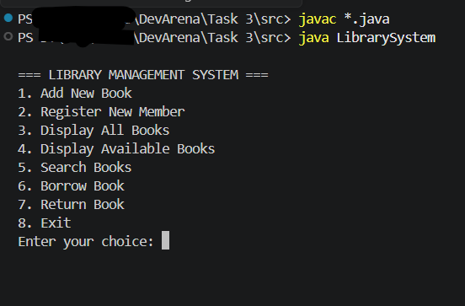

- Screenshot 2: TC-04: Borrowing book that is already borrowed
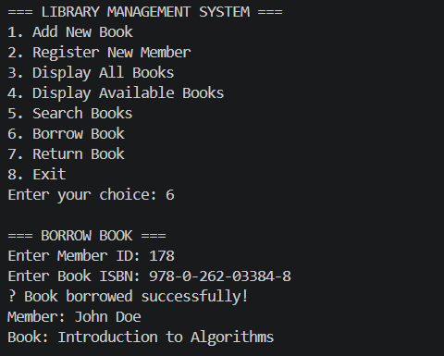
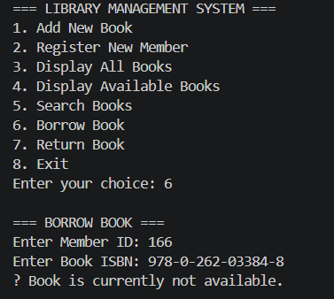

- Screenshot 3: TC-02: Searching for books using lowercase keywords
